|  |  |  |
| --- | --- | --- |
| **Data Science Project Training Report**  **on**  **RECOGNIZING HANDWRITTEN DIGITS**  **BACHELOR OF TECHNOLOGY**      **Session 2024-25 in**  **Information Technology**      **By**    **Devansh Parashar**  **2300320130087**  **Hemant Raghav**  **2300320130115**      **Dr. Shelley Gupta**  **Associate Professor**    **DEPARTMENT OF INFORMATION TECHNOLOGY**  **ABES ENGINEERING COLLEGE, GHAZIABAD** | | |
|  |  |  |
| **AFFILIATED TO**  **DR. A.P.J. ABDUL KALAM TECHNICAL**  **UNIVERSITY, U.P., LUCKNOW**  **(Formerly UPTU)** | | |

**Student’s Declaration**

I / We hereby declare that the work being presented in this report entitled **Recognizing Handwritten Digits** is an authentic record of my / our own work carried out under the supervision of **Dr. Shelley Gupta, Associate Professor, Information Technology.**

**Date: 12/12/2024**

**Devansh Parashar**

**Hemant Raghav**

**Department: Information technology**

This is to certify that the above statement made by the candidate(s) is correct to the best of my knowledge.

**Signature of HOD**  **Signature of Teacher**

**Prof. (Dr.) Amrita Jyoti Dr. Shelley Gupta**

**Information Technology** **Associate Professor**

**Information Technology**

**Date: ..........................**

**Table of Contents**

|  |  |  |
| --- | --- | --- |
| **S. No.** | **Contents** | **Page No.** |
| **1** | Student’s Declaration | i |
| **2** | Abstract | 1 |
| **3** | Introduction | 2-3 |
| **4** | Literature review | 4 |
| **5** | Implementation | 5-6 |
| **6** | Data Visualization | 7-9 |
| **10** | Prediction models | 10-12 |
| **11** | Conclusion | 13 |
| **12** | Future work | 14 |
| **14** | References | 15 |

# Abstract

The objective of this project is to create a robust system capable of recognizing handwritten digits from images. Handwritten digit recognition poses a unique challenge due to the variability in human handwriting, including differences in size, thickness, and style. To address these challenges, we employ CNNs, which are particularly adept at detecting patterns in visual data.

Handwritten digit recognition is a significant area of research in machine learning and computer vision, focusing on the ability of computers to identify and classify digits written by humans. This project report outlines the development and implementation of a handwritten digit recognition system utilizing neural networks, particularly convolutional neural networks (CNNs).

*Keywords-* Handwritten Digit Recognition, Optical Character Recognition (OCR**)**, Image Processing, Pattern Classification, Computer Vision

# 

# Introduction

The shopping sector has greatly evolved due to the Internet revolution. Most of the population takes into consideration online shopping more than the traditional method of shopping. The biggest perks of online shopping are convenience, better prices, more variety, easy price comparisons, no crowds, etc. The pandemic has boosted online shopping. Though online shopping keeps growing every year, the total sales for the year 2021 are expected to be much higher [16]. Black Friday originated in the USA and is also referred to as Thanksgiving Day. This sale is celebrated on the fourth Thursday of November once every year. This day is marked as the busiest day in terms of shopping. The purpose of organizing this sale is to promote customers to buy more products online to boost the online shopping sector. The prediction model built will help to analyse the relationship among various attributes. Black Friday Sales.

Dataset is used for training and prediction. Black Friday Sales Dataset is the online biggest dataset and the dataset is also accepted by various e-commerce websites [1]. The prediction model built will provide a prediction based on the age of the customer, city category, occupation, etc. The prediction model is implemented based on models like linear regression, Decision Tree Regressor, Random Forest Regressor.



Fig 1. Factors affecting purchase

*Machine Learning* **-:** Machine learning is a branch of artificial intelligence that learns data from computer-based models to discover hidden insights. There are two major types of machine learning: supervised learning and unsupervised learning.

1. Supervised learning: Class labels or predictor values can be determined based on features. If the labels are continuous, then these models are said to belong to regression; if the labels are categorical, then the models are said to belong to classification.
2. Unsupervised learning: Class labels or prediction values are unknown.

c)Reinforcement learning: Reinforcement learning (RL) is an area of machine learning concerned with how intelligent agents ought to take actions in an environment in order to maximize the notion of cumulative reward.

# Literature review

Handwritten digit recognition (HDR) is a significant area of research within the fields of computer vision and machine learning, primarily due to its applications in various domains such as banking, postal services, and document digitization. This literature review synthesizes key findings from recent studies on HDR, focusing on methodologies, challenges, and advancements in the field.

*Techniques and Methods :-*

*Machine Learning Approaches*

1. *Support Vector Machines (SVM):* SVMs are commonly used for classification tasks in HDR. They have shown high accuracy rates, with some studies reporting up to 97.16% accuracy using SVM classifiers on specific datasets.
2. *Multilayer Perceptron (MLP):* This neural network model has also been employed for HDR, achieving notable accuracy levels. For instance, one study reported an accuracy of 90.37% using MLP on a dataset from the Austrian Research Institute for Artificial Intelligence.
3. *K-Nearest Neighbours (KNN):* Another algorithm explored in HDR literature, KNN has been compared with other methods to assess its effectiveness in recognizing handwritten digits

*Deep Learning Techniques*

1. *Convolutional Neural Networks (CNN):* CNNs are increasingly popular for HDR due to their ability to automatically extract features from images. They have achieved remarkable performance, with some models reporting recognition rates as high as 99.85%.
2. *Efficient Det:* A recent study introduced a deep learning-based technique using Efficient Det for numeral categorization, which aims to overcome limitations related to writing style variations and image artifacts

## Implementation

## *Convolutional Neural Networks (CNNs)*

CNNs are widely used for image classification tasks, including handwritten digit recognition. They are particularly effective due to their ability to learn hierarchical features from images. The architecture typically involves multiple layers:

*Convolutional Layers*: These layers extract features from the input images by applying filters that capture local patterns, such as edges.

*Pooling Layers:* These reduce the dimensionality of the feature maps, retaining essential information while discarding less important details.

*Fully Connected Layers*: At the end of the network, these layers classify the extracted features into the digit classes.

Recent implementations have achieved high accuracy rates; for instance, a CNN model reported an accuracy of **99.15%** on handwritten digit recognition tasks using the MNIST dataset.

*Dataset Utilization :-*

The MNIST dataset is the standard benchmark for training and testing handwritten digit recognition systems. It contains 60,000 training images and 10,000 test images of handwritten digits.

The images are grayscale and normalized to a size of 28×2828×28 pixels, which simplifies processing and improves model performance.

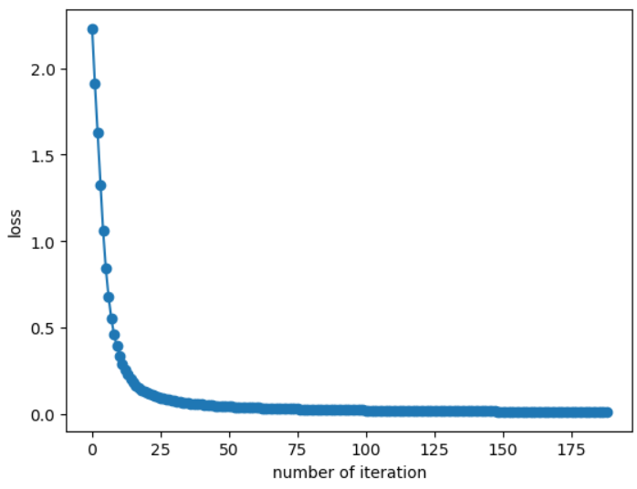

Fig 2. Line Graph

*Implementation Steps:* **-**

1. *Data Preprocessing:*
   * Convert images to grayscale.
   * Normalize pixel values to a range of [0, 1].
   * Reshape images into a suitable format for CNN input.
2. *Model Building*:
   * Use frameworks like TensorFlow or Kera to construct the CNN architecture.
   * Define layers with appropriate activation functions (e.g., soft max for the output layer).
3. *Training:*
   * Split the dataset into training and validation sets.
   * Train the model using backpropagation and optimization techniques such as Adam or SGD (Stochastic Gradient Descent).
   * Monitor performance using metrics like accuracy and loss.
4. *Testing:*
   * Evaluate the model on unseen test data.
   * Adjust hyperparameters based on performance metrics to improve accuracy.
5. *Deployment:*
   * Integrate the trained model into applications where users can input handwritten digits via a graphical interface or through scanned documents

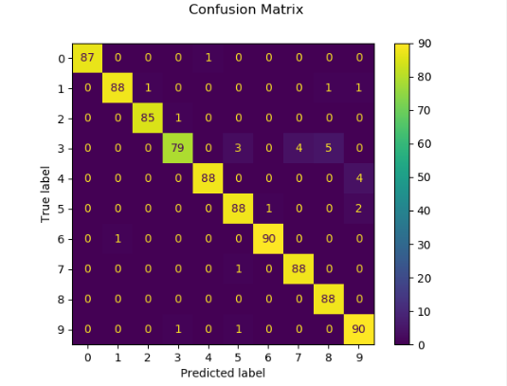

Fig 3. Prediction Label

# 

# Fig 4. Scatter Plot

# The perceptron is a type of artificial neural network that was developed by Frank Posenblatt in the 1960s. It takes in multiple binary inputs (x1, x2, ... xn) and produces a binary output. The output of the perceptron is determined by whether the sum of the weighted inputs is above or below the threshold value.

# 

Fig 5. Structure of artificial neural network (ANN)

Artificial neural networks (ANNs) are inspired by the structure and function of biological neural networks, ANNs are capable of making decisions and judgments in a manner similar to human thinking and have many characteristics of biological systems, such as robustness, high parallelism, nonlinearity, fault tolerance, and good learning ability. In many cases, ANNs are more reliable than traditional logical reasoning methods.

# 

# Fig 6. CNN model based on LeNet-5

The convolutional neural network used in this system is based on the LeNet-5 model [8-9], which was developed by Yann LeCun in 1998 for recognition of handwritten digits. At the time, it was widely used by US banks to process check transactions. LeNet-5 is a pioneering example of a convolutional neural network and remains one of the most well-known models in the field.

It shows that LeNet-5 is composed of two convolutional layers, two pooling layers, and one fully connected layer. The operations of C1, S2, C3, and S4. The number of feature maps produced by the pooling layers is fixed, while the number of feature maps in the convolutional layers is not dependent on the previous layer. For example, the C1 layer uses six trainable digital filters to create six feature maps, and the C3 layer combines all 12 feature maps from the S2 layer to create its own set of 12 feature maps. The fully connected layer takes the output of S4 and flattens it into a 1x10 one-dimensional vector.

# Data Visualization

Objectives and Applications: -

The main aim of these projects is to implement classification algorithms capable of recognizing handwritten digits. The applications of such systems are extensive, including:

* Automated bank check processing
* Postal address recognition
* Data entry for forms (e.g., tax documents)

These applications highlight the significance of accurate digit recognition in various industries, particularly in automating processes that involve handwritten inputs.

Methodologies Used

Machine Learning Algorithms

1. *Support Vector Machines (SVM)*
   * Achieved an accuracy of approximately 95% in some implementations
2. *K-Nearest Neighbours (KNN)*
   * Reported accuracy around 96.67%
3. *Random Forest Classifier (RFC)*
   * Achieved an accuracy of about 96.89%

Deep Learning Techniques :-

1. *Convolutional Neural Networks (CNN)*
   * CNNs have become the dominant approach due to their high accuracy rates, achieving up to 98.85% on the MNIST dataset
   * These networks effectively handle variations in handwriting styles, sizes, and orientations.

*Dataset*

The MNIST dataset is predominantly used for training and testing models. It consists of:

* 60,000 training images and 10,000 testing images of handwritten digits.
* Each image is a 28x28 pixel grayscale representation of a digit

*Results*

The projects consistently report high accuracy rates:

* CNNs generally outperform traditional machine learning algorithms, with accuracies reaching up to 98.70% using frameworks like Kera with TensorFlow
* The performance metrics often include training and validation accuracy graphs, loss curves, and confusion matrices to illustrate the effectiveness of the models employed.

*Challenges Faced*

Several challenges complicate handwritten digit recognition:

* Variability in handwriting styles (size, thickness, orientation).
* Noise and distortion in images that can affect recognition accuracy.
* The need for preprocessing steps to enhance image quality before classification.

# Conclusion

The recognition of handwritten notes, also known as handwriting recognition (HWR), has seen significant advancements due to the integration of various technologies and methodologies. The conclusion drawn from recent studies highlights several key aspects:

*1. Importance of Preprocessing:*  
Preprocessing is critical for enhancing recognition accuracy. This stage involves normalizing strokes, correcting slants, and removing noise from the input data, which significantly impacts the performance of subsequent stages in the recognition process Effective preprocessing techniques help in standardizing the input, making it easier for classification algorithms to perform accurately.

*2.**Segmentation Challenges:*  
Character segmentation remains one of the most challenging aspects of handwriting recognition. Many systems have transitioned to treating segmentation as an object detection problem, utilizing advanced techniques such as Faster-CNN to improve accuracy in character segmentation this shift allows for more robust handling of diverse handwriting styles and layouts.

*3.**Feature Extraction and Classification:*  
The choice of features extracted from handwritten text plays a crucial role in the overall effectiveness of recognition systems. Various methodologies, including neural networks and hybrid models, have been employed to enhance feature extraction processes. Studies indicate that using a combination of different features can lead to improved classification rates, with some systems achieving accuracies above 97%.

# FUTURE WORK

# 

Handwritten digit recognition (HDR) is a critical area in computer vision and machine learning, with applications ranging from automated data entry to postal services. The future of HDR is poised for significant advancements through various methodologies and technologies.

1. *Integration of Hardware Solutions:* There is potential for future work to explore hardware implementations of HDR systems, which could enhance real-time recognition capabilities
2. *Advanced Learning Techniques:* Research into few-shot learning and continual learning could provide frameworks for systems to learn from limited data or adapt over time without extensive retraining
3. *Ethical Considerations:* As HDR systems become more prevalent, addressing ethical concerns related to data privacy and algorithmic bias will be crucial
4. *Expanding Recognition Capabilities*: Future systems could be designed not only for digit recognition but also for recognizing handwritten characters and symbols, broadening the application scope of HDR technologies
5. *Improved Accuracy Metrics:* Developing new metrics to evaluate the performance of HDR systems beyond traditional accuracy rates could provide deeper insights into their effectiveness across diverse datasets and conditions.

# GITHUB REPOSITORY LINK

# Devansh Parashar

# <https://github.com/DevanshParashar165>

# Hemant Raghav

# <https://github.com/hemantraghav-123>

# REFERENCES

[[1]](https://www.sciencedirect.com/science/article/pii/S2214579620300502#bbr0020) M. Revow C.K.I. Williams, G.E. Hinton

Using generative models for handwritten digit recognition

IEEE Trans. Pattern Anal. Mach. Intel., 18 (6) (1996), pp. 592-606

[2] F.C. Ribas, L.S. Oliveira, A.S. Britto Jr, R. Sabourin

Handwritten digit segmentation: a comparative study

Int. J. Doc. Anal., 16 (2013), pp. 127-137

[3] D. Ciresan

Avoiding segmentation in multi-digit numeral string recognition by combining single and two-digit classifiers trained without negative examples

International Symposium on Symbolic and Numeric Algorithms for Scientific Computing, IEEE (2008), pp. 225-230

[View at publisher](https://doi.org/10.1109/SYNASC.2008.68) [Cross ref](https://doi.org/10.1109/SYNASC.2008.68) [View in Scopus](https://www.scopus.com/inward/record.url?eid=2-s2.0-70449558961&partnerID=10&rel=R3.0.0) [Google Scholar](https://scholar.google.com/scholar_lookup?title=Avoiding%20segmentation%20in%20multi-digit%20numeral%20string%20recognition%20by%20combining%20single%20and%20two-digit%20classifiers%20trained%20without%20negative%20examples&publication_year=2008&author=D.%20Ciresan)

[4] K.K. Kim, J.H. Kim, C.Y. Suen

Segmentation-based recognition of handwritten touching pairs of digits using structural features

Pattern Recognit Lett., 23 (1) (2002), pp. 13-24

[5] Y. LeCun, C. Cortes, C.J. Burges

<http://yann.lecun.com/exdb/mnist> (2010)

[6] J.J. Hull

A database for handwritten text recognition research

IEEE Trans. Pattern Anal. Mach. Intel., 16 (5) (1994), pp. 550-554

[7] S. Ren, K. He, R. Girshick J. Sun

Faster R-CNN: towards real-time object detection with region

proposal networks

Computer Vision and Pattern Recognition Workshops, IEEE (2016)

[8] Published in**:**

[2023 International Conference on Innovative Computing, Intelligent Communication and Smart Electrical Systems (ICSES) - Conference Table of Contents | IEEE Xplore](https://ieeexplore.ieee.org/xpl/conhome/10464384/proceeding)

Date of Conference: 14-15 December 2023

Date Added to IEEEXplore**:**19 March 2024

DOI:[10.1109/ICSES60034.2023.10465327](https://doi.org/10.1109/ICSES60034.2023.10465327)

Publisher IEEE

[9] Recognition of Handwritten Digit using Convolutional Neural Network (CNN)

May 2019

[Global Journal of Computer Science and Technology](https://www.researchgate.net/journal/Global-Journal-of-Computer-Science-and-Technology-0975-4172?_tp=eyJjb250ZXh0Ijp7ImZpcnN0UGFnZSI6InB1YmxpY2F0aW9uIiwicGFnZSI6InB1YmxpY2F0aW9uIn19) 19(2):27-33

DOI:[10.34257/GJCSTDVOL19IS2PG27](http://dx.doi.org/10.34257/GJCSTDVOL19IS2PG27)

[10] Salvador España-Boquera, Maria J. C. B., Jorge G. M. and Francisco Z. M., “Improving Offline Handwritten Text Recognition with Hybrid HMM/ANN Models”, IEEE Transactions on Pattern Analysis and Machine Intelligence, Vol. 33, No. 4, April 2014.